AI-ENHANCED DATA VISUALIZATION USING POWER BI

A PROJECT REPORT
Submitted in partial fulfilment of the requirements
for the award of the degree of

MASTER OF COMPUTER APPLICATIONS

IN
Department of Computer Science and Applications

BY

Gorantla Naveen
(2401600196)

UNDER THE SUPERVISION OF
Dr. Kalimuthu
Professor



DEPARTMENT OF COMPUTER APPLICATIONS
K L E F, Green Fields,
Vaddeswaram, Guntur,
Andhra Pradesh, India – 522502

2025 – 2026

KONERU LAKSHMAIAH EDUCATION FOUNDATION

DEPARTMENT OF COMPUTER APPLICATIONS



DECLARATION

The Project Report entitled “AI-ENCHANCED DATA VISUALIZATION BY USING POWER BI” is a record of Bonafide work of Gorantla Naveen, submitted in partial filaments for the award of Master of Computer Applications in Computer Science and Applications of the K L University. The results embodied in this report have not been copied from any other departments/University/Institute.

Signature of the Student
Gorantla Naveen
(2401600196)

KONERU LAKSHMAIAH EDUCATION FOUNDATION

DEPARTMENT OF COMPUTER APPLICATIONS



CERTIFICATE

This is to certify that the Project Report entitled “AI-ENCHANCED DATA VISUALIZATION BY USING POWER BI ” is being submitted by Gorantla Naveen, in partial fulfillment of the requirements for the award of Master of Computer Applications in Computer Science and Applications to the K L Education Foundation is a record of Bonafide work carried out under our guidance and supervision. The results embodied in this report have not been copied from any other departments/ University/ Institute.

Signature of the Supervisor Signature of the HOD

(Dr. Kalimuthu sir) ( Chunduri Kiran Kumar)

Professor Professor & HOD

Signature of the Examiner

ACKNOWLEDGEMENT

The satisfaction that accompanies the successful completion of any task would be incomplete without the mention of people who made it possible and whose constant guidance and encouragements crown all the efforts with success.

I am very thankful to our project guide Dr. Kalimuthu, Professor for her continuous support and encouragement in completing the Project work. Without her help the project couldn’t have been completed.

I express our heartful gratitude to Chunduri Kiran Kumar , Head of the Department of Computer Applications for providing us with adequate facilities, ways and means by which we are able to complete this project.

I express our heartful gratitude to Dr. Kishore Babu(Dean,MHS), l College of Sciences, for providing us with adequate facilities, ways and means by which we can complete this project.

Last but not the least, we thank all Teaching and Non-Teaching Staff of our department and especially my classmates and my friends for their support in the completion of our project.

Signature of the Student

Gorantla Naveen

(2401600196)

CONTENTS
S. No TITLE PAGE NO
- Abstract 9
- Introduction 10-11
2.1 Motivation
2.2 Problem Statement
2.3 Objectives of the Project
2.4 Scope of the Project
2.5 Project Overview
- Literature Survey 12-13
3.1 Related Work
3.2 Research Papers on Data Visualization
- System Analysis 13-15
4.1 Existing System
4.2 Disadvantages of Existing System
4.3 Proposed System
4.4 Advantages of Proposed System
4.5 Workflow of Proposed System
- Requirement Analysis 15-18
5.1 Functional Requirements
5.2 Non-Functional Requirements
5.3 Hardware Requirements
5.4 Software Requirements
5.5 System Architecture
- System Design 18-26
6.1 Input Design
6.2 Output Design
6.3 UML Diagrams
6.3.1 Use Case Diagram
6.3.2 Class Diagram
6.3.3 Sequence Diagram
6.3.4 Activity Diagram
6.3.5 Component Diagram
6.3.6 Deployment Diagram
6.3.7 ER Diagram
6.3.8 Result
6.4 Data Flow Diagram 26-29
6.4.1 DFD Level 0
6.4.2 DFD Level 1
6.4.3 DFD Level 2
7. Implementation and Results 30-32
7.1 Modules
7.1.1 Data Collection Module
7.1.2 Data Processing Module
7.1.3 Visualization Module
7.1.4 Dashboard Module
7.2 Dashboard Screens 32-34
7.2.1 COVID-19 Cases Visualization
7.2.2 Death Rate Analysis
7.2.3 Recovery Rate Visualization
7.2.4 Country Comparison Charts
8 System Study and Testing 34-35
8.1 Feasibility Study
8.1.1 Economic Feasibility
8.1.2 Technical Feasibility
8.1.3 Social Feasibility
8.2 System Testing 36-44
8.2.1 Unit Testing
8.2.2 Integration Testing
8.2.3 Functional Testing
8.2.4 White Box Testing
8.2.5 Black Box Testing
- Power BI Implementation Code 45-49
- Dashboard Explanation 50
- Conclusion 51
- Future Enhancements 52
13 References 53-57

1.Abstract
The COVID-19 pandemic generated an unprecedented volume of data related to confirmed cases, deaths, and recoveries across different regions, making it challenging for users to interpret trends and derive meaningful insights from raw numbers alone. Analyzing this data is crucial for understanding the spread of the virus, evaluating its impact, and supporting informed decision-making. This project, titled “AI-Enhanced Data Visualization for COVID-19 Analysis,” addresses this challenge by combining effective data visualization techniques with AI-assisted analytical features to present complex COVID-19 data in a clear and interactive manner. The primary objective of this work is to design an intuitive visualization system that enables users to easily explore pandemic related data, identify trends, and gain insights without requiring advanced technical knowledge. The dataset's is collected from reliable public sources and undergoes data cleaning, transformation, and prepossessing to ensure accuracy and consistency. Power BI is used as the main visualization tool to develop interactive dashboards displaying key metrics such as daily and cumulative cases, deaths, recoveries, and regional comparisons. In addition, An enhanced features such as automated insights, trend detection, and basic forecasting are applied to highlight patterns and potential future trends in the data. The expected outcome of this project is a user-friendly and visually appealing dashboard that simplifies the understanding of COVID-19 data and supports better analytical interpretation. This system is especially useful for students, researchers, and general users who wish to study pandemic trends and impacts through an interactive and AI-supported visualization approach.

Keywords: COVID-19, Data Visualization, Power BI, Artificial Intelligence, Trend Analyst

2. Introduction
Data visualization plays a crucial role in understanding large amounts of data quickly and effectively. In today’s digital world, organizations generate huge volumes of data every day. Analysing this data manually is difficult and time-consuming. Therefore, modern tools like Power BI combined with Artificial Intelligence help transform raw data into meaningful insights through visual dashboards and reports.
The project “AI-Enhanced Data Visualization using Power BI” focuses on creating interactive dashboards that help users analyse data easily. Power BI provides powerful visualization capabilities, while AI techniques help in identifying trends, patterns, and predictions from the data.
This project demonstrates how AI-based features such as automated insights, data modelling, and smart analytic can improve decision-making processes. The system enables users to view data in the form of charts, graphs, and reports, making it easier to understand complex datasets.

2.1 Motivation
The motivation behind this project is the increasing need for efficient data analysis and visualization in organizations. Traditional data analysis methods require a lot of manual effort and technical expertise. Many organizations struggle to convert large datasets into meaningful insights.
With the help of Power BI and AI technologies, data can be analyzed automatically and presented in a visual format that is easy to understand. This project aims to demonstrate how intelligent visualization tools can help businesses and individuals make better decisions based on data.

2.2 Problem Statement
Many organizations collect large amounts of data but face difficulties in analyzing and understanding it effectively. Raw data stored in spreadsheets or databases is often complex and difficult to interpret.
Without proper visualization tools, identifying patterns, trends, and important insights becomes challenging. This project addresses the problem by using Power BI along with AI-based features to transform raw data into clear and interactive visual dashboards.

2.3 Objectives of the Project
The main objectives of this project are:
- To understand the concept of data visualization using Power BI.
- To integrate AI-based analytical features for better insights.
- To design interactive dashboards for effective data representation.
- To help users easily analyse large datasets through visual reports.
- To demonstrate how data-driven decisions can be made using visualization tools.

2.4 Scope of the Project
The scope of this project is focused on developing an AI-enhanced data visualization system using Power BI. The project includes data collection, data processing, and the creation of dashboards that display insights through charts, graphs, and reports.
The system can be used for analyzing business data, sales data, or other datasets to identify trends and patterns. Although the project focuses mainly on visualization, it can be extended in the future to include predictive analytic and advanced machine learning techniques.

2.5 Project Overview
The project involves the use of Power BI to build interactive dashboards and visual reports. Data from different sources is first collected and cleaned before being loaded into Power BI. After the data is processed, various visualizations such as bar charts, pie charts, line graphs, and tables are created.
AI-based features in Power BI help in generating automated insights and identifying important patterns in the dataset's. The final output of the project is a user-friendly dashboard that allows users to explore data visually and gain valuable insights for better decision-making.

3. Literature Survey

A literature survey is the study of previous research related to the project topic. It helps in understanding how other researchers have worked on data visualization and business intelligence tools. Data visualization converts raw data into graphical formats such as charts, graphs, and dashboards. This makes it easier for users to understand complex information.
Many modern organizations use visualization tools like Power BI to analyse large datasets and generate useful insights. These tools help in presenting data in an interactive and understandable form. The literature survey shows that visualization plays an important role in improving decision-making and data analysis.
3.1 Related Work
International Journal of Advanced Science and Technology
Vol. 29, No. 6 (2020), pp. 4783–4786
- A. Smith and B. Johnson, “Data Visualization Techniques for Business Intelligence,” International Journal of Advanced Science and Technology, 2020.
• Discusses different data visualization techniques used in business intelligence systems and explains how visual dashboards improve data understanding.
- R. Kumar and P. Singh, “Interactive Data Visualization using Power BI,” International Journal of Computer Applications, vol. 182, no. 12, 2019.
• Explains the use of Power BI to create interactive dashboards and reports for analysis business and organizational data.
- S. Patel et Al., “Business Intelligence and Data Analytic using Power BI,” International Journal of Innovative Technology and Exploring Engineering (IJITEE), vol. 9, no. 6, 2020.
• Describes how Power BI helps organizations transform raw data into meaningful insights through charts, graphs, and dashboards.
- Dr. K. Ra mesh et Al., “AI-Based Data Visualization for Smart Decision Making,” International Journal of Research Publication and Reviews, vol. 4, no. 5, 2023.
• Presents the integration of Artificial Intelligence with data visualization tools to automatically detect patterns and generate analytical insights.
5.P. Sharma and V. Gupta, “Modern Data Visualization Tools for Business Analytic,” International Journal of Data Science and Analytic, vol. 5, no. 3, 2022.

3.1 Related Work
Several researchers have worked on data visualization systems using business intelligence tools. Their studies show that visual dashboards help users easily understand large datasets. These systems use charts, graphs, and reports to present important information clearly.
Researchers also found that visualization tools help organizations monitor performance, analyse trends, and identify patterns in data. By using visualization techniques, businesses can make faster and more accurate decisions.

4. System Analysis

System analysis is the process of studying the existing system and identifying its limitations. It also helps in designing a better system that solves the problems of the current system. In this project, the analysis focuses on how data is currently analyzed and how Power BI with AI features can improve the process of data visualization.

4.1 Existing System
In the existing system, data is mostly stored in spreadsheets or databases and analyzed manually. Users often use basic tools like Excel tables and static charts to understand the data. These methods require manual effort and technical knowledge to analyse large datasets.
The existing system lacks interactive dashboards and automated insights. Users must spend a lot of time cleaning data, analyzing trends, and generating reports. Because of this, understanding complex data becomes difficult and time-consuming.

4.2 Disadvantages of Existing System

- Manual data analysis takes more time.
- Difficult to analyse large datasets efficiently.
- Lack of interactive dashboards and reports.
- Limited visualization options.
- Hard to identify patterns and trends quickly.
- Decision-making becomes slower due to complex data interpretation.

4.3 Proposed System
The proposed system uses Power BI with AI-enhanced features to analyse and visualize data. In this system, data is collected from different sources and processed using Power BI. The tool transforms raw data into meaningful insights through interactive dashboards and visual reports.
AI features in Power BI help in automatically detecting trends, patterns, and important insights. Users can easily explore data through charts, graphs, and dashboards, which improves understanding and decision-making.

4.4 Advantages of Proposed System
- Provides interactive dashboards for better data understanding.
- Reduces manual effort in analysing data.
- Helps identify trends and patterns quickly.
- Improves decision-making through visual insights.
- Supports analysis of large datasets efficiently.
- User-friendly interface for easy data exploration.

4.5 Workflow of Proposed System
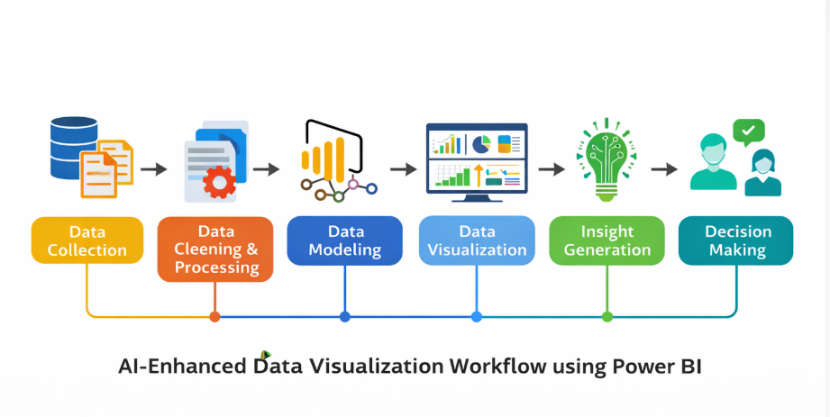

5. Requirement Analysis

Requirement analysis is the process of identifying the needs and requirements of a system before developing it. It helps to understand what the system should do and what resources are required to implement it. In this project, the requirement analysis focuses on the functional and non-functional needs of the AI-enhanced data visualization system using Power BI.

5.1 Functional Requirements

Functional requirements describe the main operations that the system must perform.
- The system should collect data from different sources such as Excel files, databases, or datasets.
- The system should allow users to load and transform data in Power BI.
- The system should create interactive visualizations such as charts, graphs, and dashboards.
- The system should analyse data and generate insights using Power BI features.
- The system should allow users to view reports and dashboards for decision making.

5.2 Non-Functional Requirements

Non-functional requirements describe the performance and quality attributes of the system.
- The system should be user-friendly and easy to operate.
- The system should provide fast data processing and visualization.
- The system should be reliable and accurate in generating insights.
- The system should support large datasets.
- The system should ensure data security and integrity.

5.3 Hardware Requirements

The following hardware components are required to implement the system:
- Processor: Intel Core i3 or higher
- RAM: Minimum 4 GB (8 GB recommended)
- Hard Disk: Minimum 500 GB
- Monitor: Standard display monitor
- Input Devices: Keyboard and Mouse

5.4 Software Requirements

The following software tools are required:
- Operating System: Windows 10 or above
- Power BI Desktop
- Microsoft Excel (for dataset preparation)
- Web Browser (Chrome / Edge)
- Programming Language (optional): Python for data preprocessing
5.5 System Architecture

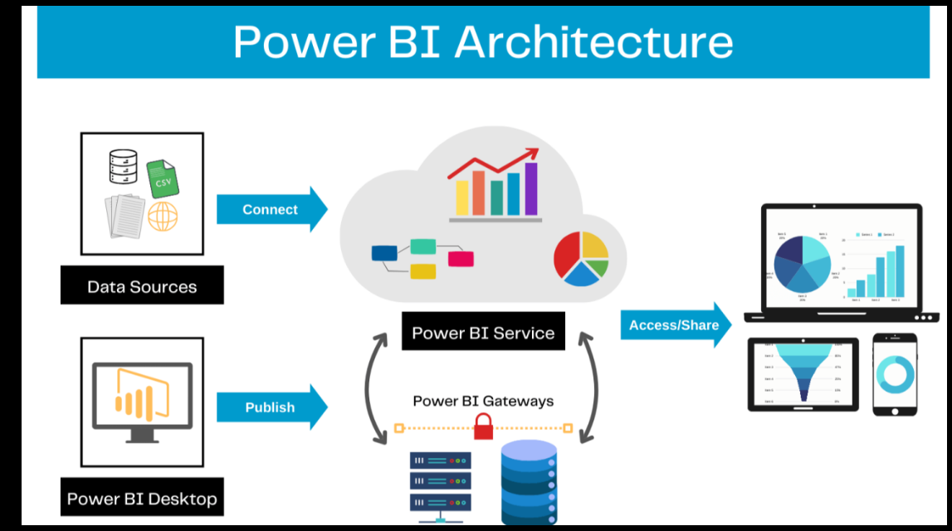

6. System Design
System design describes the overall structure of the system and explains how different components interact with each other. It focuses on designing the input, processing, and output of the system. In this project, the system design explains how data is collected, processed, and visualized using Power BI to generate meaningful insights.

6.1 Input Design
Input design refers to the process of collecting and preparing data for analysis. In this project, data is collected from different sources such as Excel files, databases, or datasets.
The input data may include sales data, customer information, or other business-related data. This data is cleaned and formatted before being loaded into Power BI. Proper input design ensures that the data used for analysis is accurate and consistent.

6.2 Output Design
Output design focuses on how the results are presented to users. In this project, the output is presented in the form of interactive dashboards and visual reports.
Power BI provides different visualization options such as bar charts, pie charts, line graphs, tables, and KPI indicators. These visual outputs help users understand the data easily and make better decisions based on the insights generated.

6.3.1 Use Case Diagram
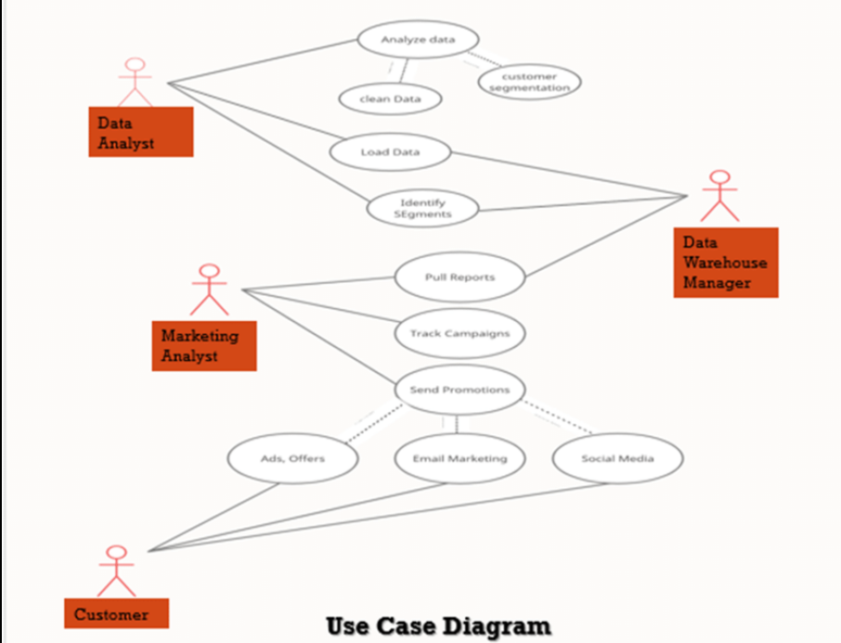
This diagram shows how users interact with the system.
The user uploads data, processes it in Power BI, and views the visual.

6.3.2 Class Diagram
The class diagram represents the structure of the system by showing different classes such as Data Source, Data Processing, Visualization, and User Interaction along with their relationships.

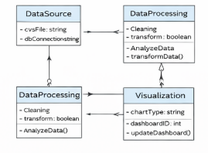

6.3.3 Sequence Diagram
The sequence diagram shows the order of operations in the system.
The process begins with data collection, followed by data processing, visualization, and finally displaying insights to the user

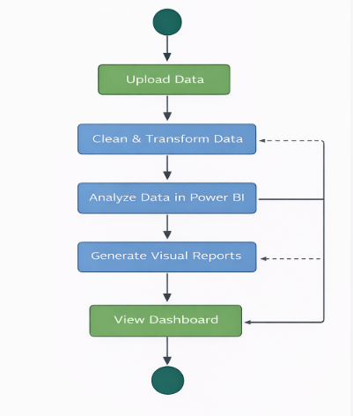

6.3.4 Activity Diagram
The activity diagram explains the workflow of the system.
It shows the steps involved in collecting data, cleaning data, analysing it in Power BI, and generating visual reports.

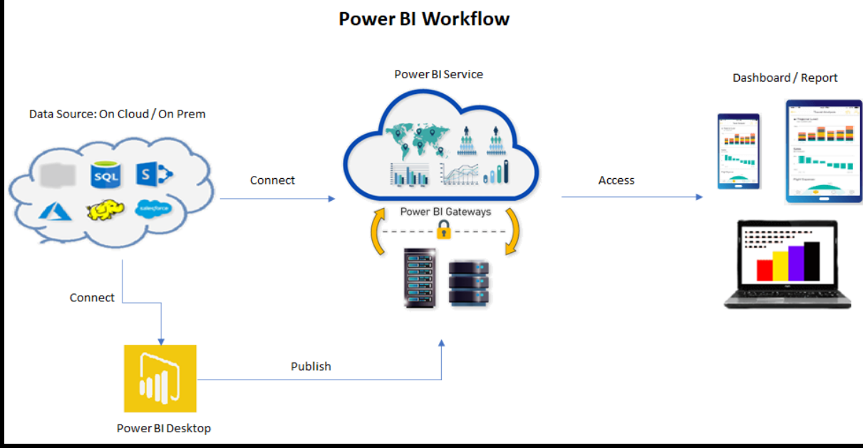

6.3.5 Component Diagram
The component diagram shows the main components of the system such as Data Source, Data Processing Module, Power BI Engine, Visualization Dashboard, and User Interface.

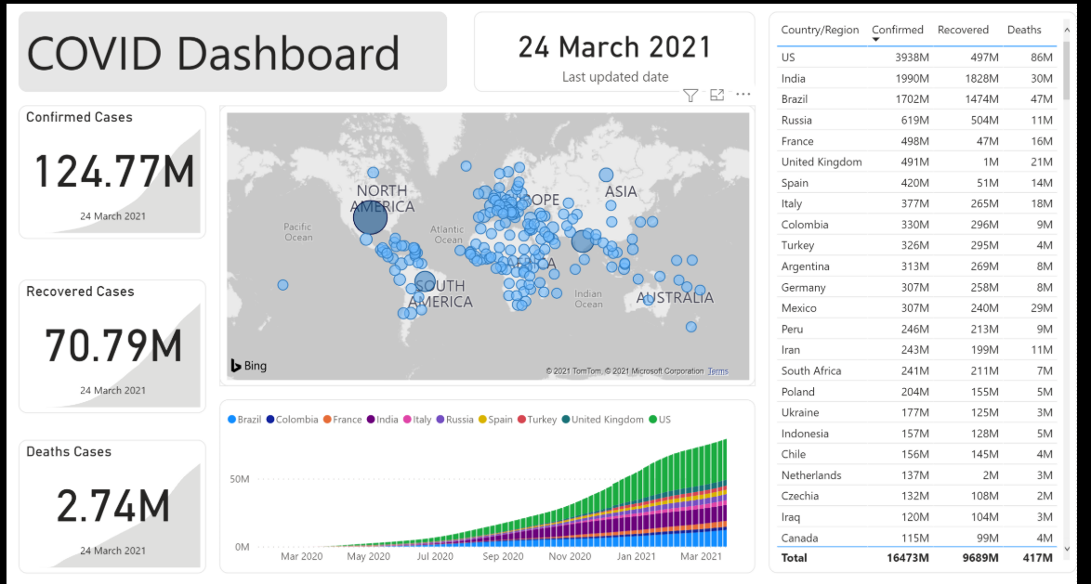

6.3.6 Deployment Diagram
The deployment diagram represents the physical deployment of the system.
It shows how Power BI software runs on a computer system where users access the dashboards and report

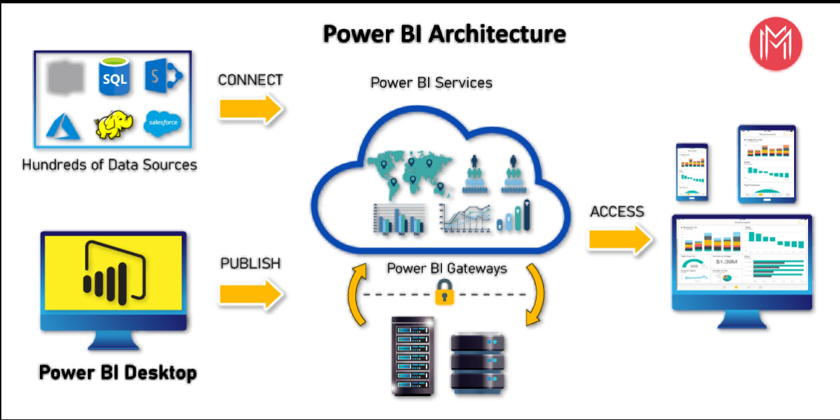

6.3.7 ER Diagram
The Entity Relationship (ER) diagram shows the relationships between different data entities such as Dataset's, Visualization, Report, and User.
It helps in understanding how data is organized and stored in the system.

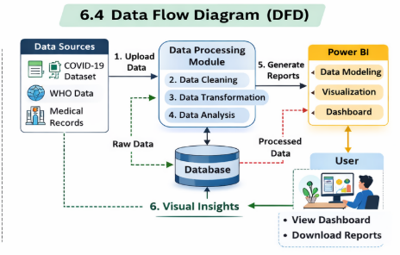

6.3.8 Result

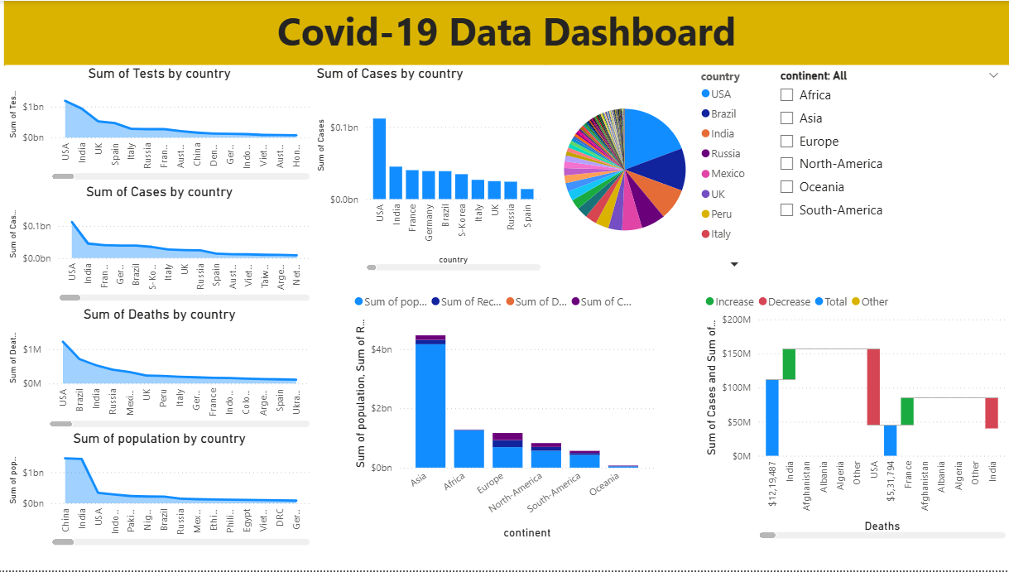

6.4 Data Flow Diagram
The Data Flow Diagram (DFD) represents how data moves through the system.
It shows the flow of data from data sources to processing and finally to visualization dashboards.

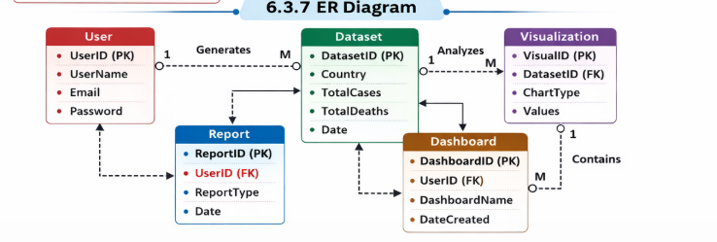

6.4.1 DFD Level 0 :
The Level 0 DFD, also known as the context diagram, represents the entire system as a single process. It shows the interaction between the user and the COVID-19 data visualization system.
In this level, the user provides the COVID-19 dataset's as input to the system. The system processes the data and generates visual dashboards and reports. The output is displayed to the user in the form of charts and graphs representing COVID-19 statistics.

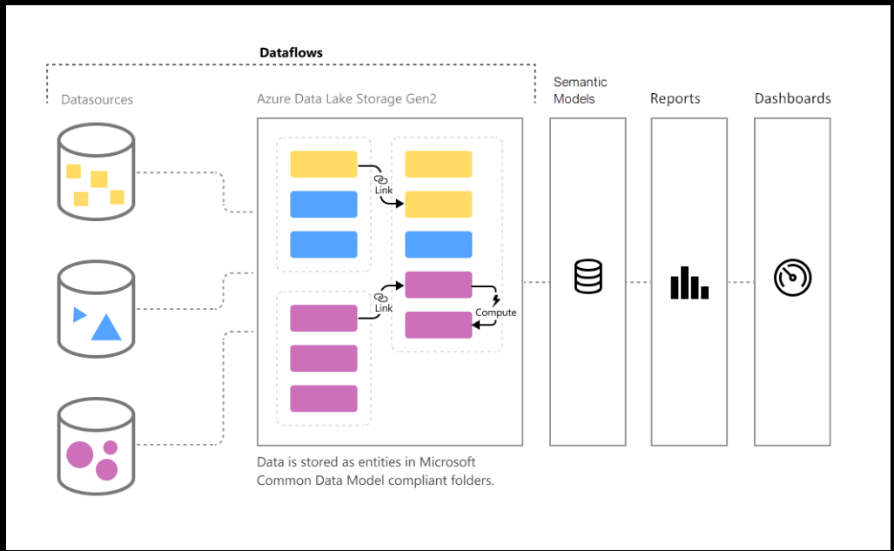

6.4.2 DFD Level 1:
The Level 1 DFD breaks down the main system process into smaller processes. It shows how the COVID-19 dataset flows through different modules of the system.
The major processes involved in this level include:
- Data Collection from COVID-19 dataset
- Data Cleaning and Processing
- Data Analysis and Modelling
- Data Visualization using Power BI
- Dashboard Display for Users

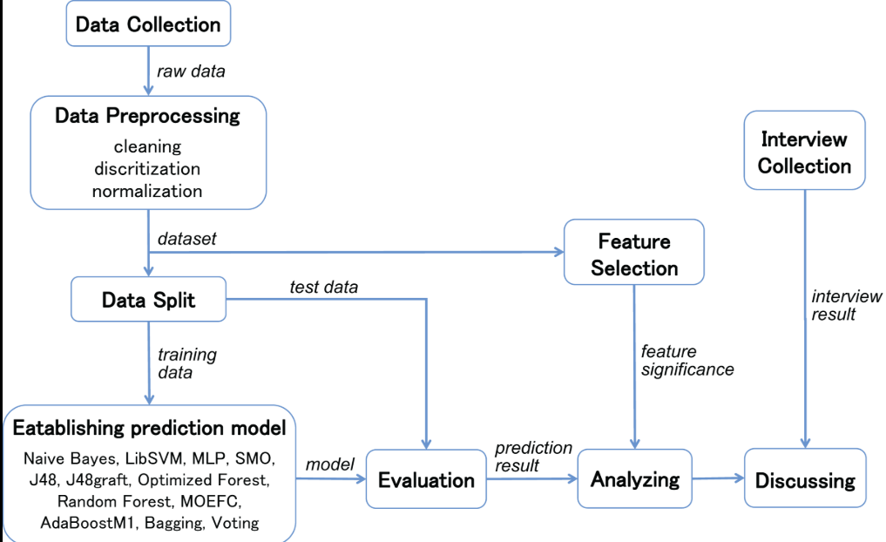

6.4.3 DFD Level 2:
The Level 2 DFD provides a more detailed view of the processes shown in Level-1. It explains how each step in the system works internally.
In this level, the COVID-19 dataset is first imported into the system. The data is then cleaned and transformed to remove missing values and organize the dataset. After processing, the data is analysed using Power BI where calculations such as total cases, deaths, and recovery rates are performed.
Finally, the processed data is converted into visual charts and dashboards which allow users to analyse COVID-19 trends effectively.

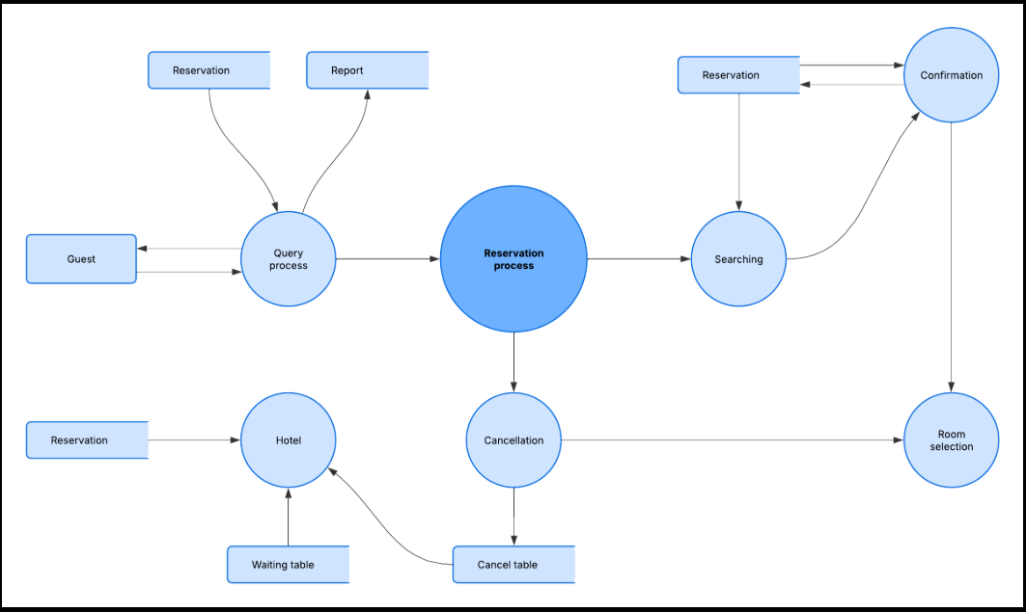

7. Implementation and Results

The implementation phase focuses on developing the COVID-19 data visualization system using Power BI. The system processes COVID-19 datasets and generates interactive dashboards that help users analyse pandemic trends such as confirmed cases, deaths, recovery rates, and country comparisons.
The COVID-19 dataset contains important fields such as Country, Date, Confirmed Cases, Deaths, and Recovered Cases. This data is imported into Power BI where it is cleaned, transformed, analyse, and visualized through interactive dashboards.

7.1 Modules:
The system is divided into four main modules to efficiently process and visualize COVID-19 data: Data Collection Module, Data Processing Module, Visualization Module, and Dashboard Module.
- Data Collection Module – Collects COVID-19 dataset from sources such as CSV or Excel files.
- Data Processing Module – Cleans and transforms the dataset's for analysis.
- Visualization Module – Creates charts and graphs using Power BI.
- Dashboard Module – Displays interactive dashboards for users to analyse COVID-19 statistics.

7.1.1 Data Collection Module
The data collection module is responsible for gathering COVID-19 data from reliable sources. The dataset's used in this project is collected in CSV or Excel format containing daily records of confirmed cases, deaths, and recoveries across different countries.

The collected data includes important attributes such as country name, date of record, number of confirmed cases, number of deaths, and number of recovered patients. This data is imported into Power BI for further processing and visualization.

7.1.2 Data Processing Module
The data processing module prepares the dataset's for analysis. During this stage, the collected data is cleaned and transformed to remove missing or incorrect values.
Power BI tools are used to perform data transformation such as filtering, sorting, grouping, and calculating totals. Important metrics such as total confirmed cases, death rate, and recovery rate are calculated. The processed dataset's is then ready for visualization.

7.1.3 Visualization Module
The visualization module converts processed data into graphical representations. Power BI provides different types of charts and graphs to represent COVID-19 data effectively.
Visualizations such as bar charts, line charts, pie charts, and maps are created to show trends and patterns in the dataset. These visualizations help users easily understand the spread and impact of COVID-19 across different countries.

7.1.4 Dashboard Module
The dashboard module displays the final visualizations in and interactive format. The Power BI dashboard combines multiple charts and reports into a single interface.
Users can interact with the dashboard by applying filters, selecting countries, or viewing trends over time. This module allows users to quickly analyse pandemic data and gain meaningful insights.

7.2 Dashboard Screens
The Power BI dashboard created in this project displays different visualizations related to COVID-19 statistics. These dashboards help users understand the pandemic trends clearly and efficiently.

7.2.1 COVID-19 Cases Visualization:
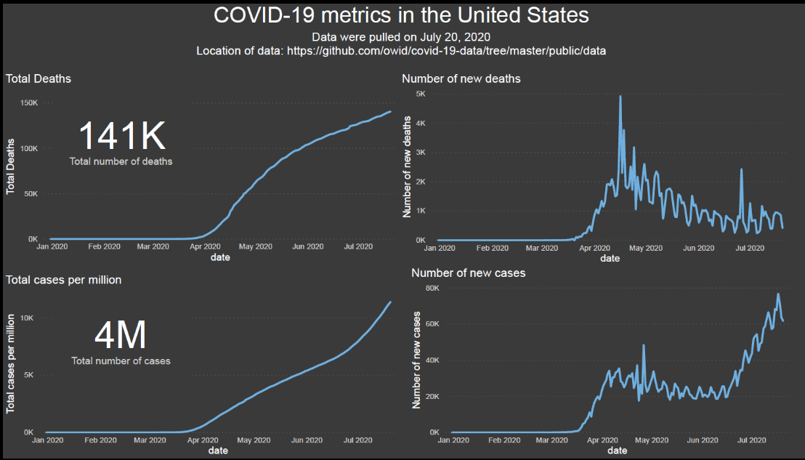
7.2.2 Death Rate Analysis:

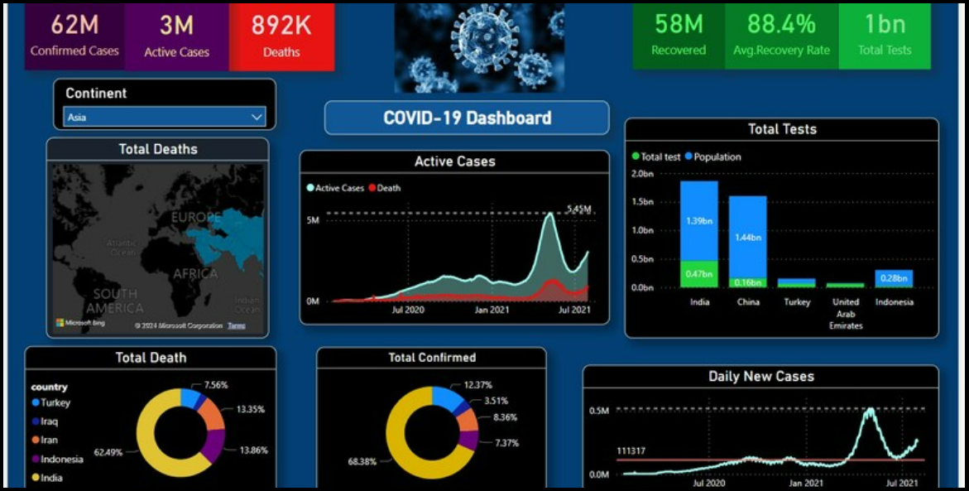

7.2.3 Recovery Rate Visualization:

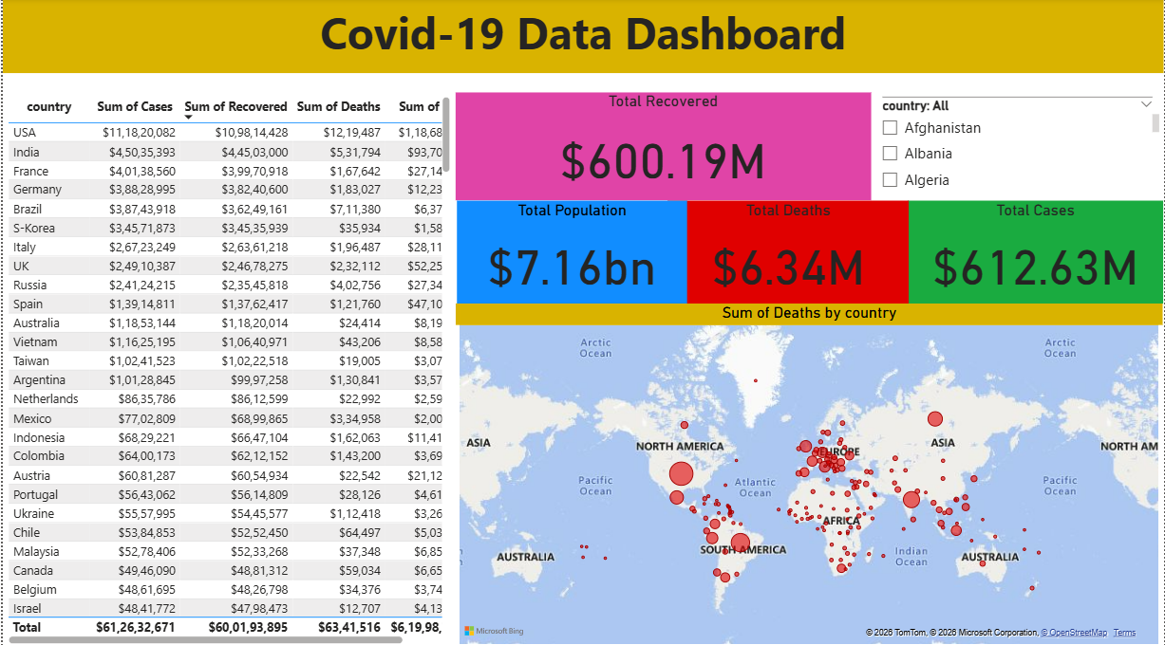
7.2.4 Country Comparison Charts:

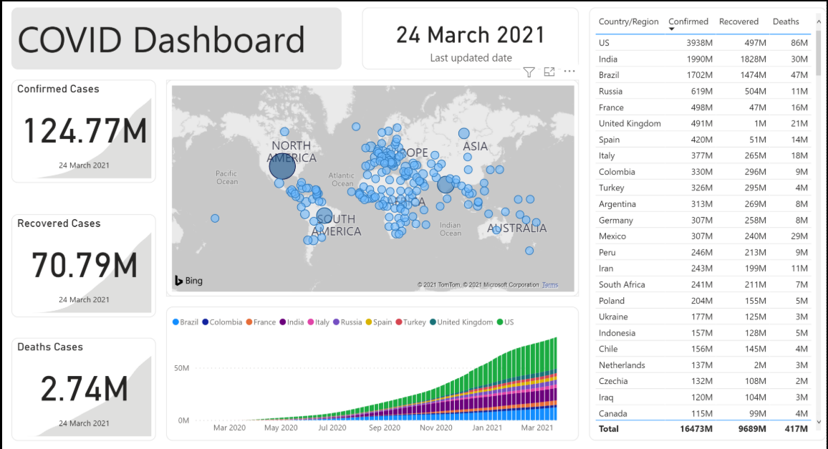

8. System Study and Testing

System study and testing help evaluate whether the proposed system works correctly and efficiently. In this project, the COVID-19 data visualization system is tested to ensure that the dataset's is correctly processed, and the Power BI dashboards generate accurate insights such as cases, deaths, and recovery statistics.

8.1 Feasibility Study
A feasibility study determines whether the proposed system is practical and beneficial. It examines the economic, technical, and social aspects of the project.

8.1.1 Economic Feasibility
The proposed COVID-19 data visualization system is economically feasible because it uses tools such as Power BI Desktop and Excel, which are either free or already available in most organizations.
The system does not require expensive hardware or infrastructure. Therefore, the cost of developing and maintaining the system is low.

8.1.2 Technical Feasibility
Technical feasibility determines whether the required technologies are available to implement the system.
The system uses technologies such as:
- Power BI Desktop
- Excel / CSV COVID-19 dataset
- Standard computer systems

These tools provide built-in data processing and visualization capabilities, making the implementation technically feasible.

8.1.3 Social Feasibility
The COVID-19 visualization system is socially beneficial because it helps users easily understand pandemic trends through graphical dashboards.
It supports awareness and decision-making by presenting information such as infection rates, death statistics, and recovery rates in an easy-to-understand visual format.

8.2 System Testing
System testing ensures that the COVID-19 data visualization system functions correctly and generates accurate dashboard results.

8.2.1 Unit Testing:
Unit testing is performed to verify that each module of the system works correctly.
In this project, individual modules such as data collection, data processing, visualization, and dashboard generation are tested separately to ensure proper functionality.
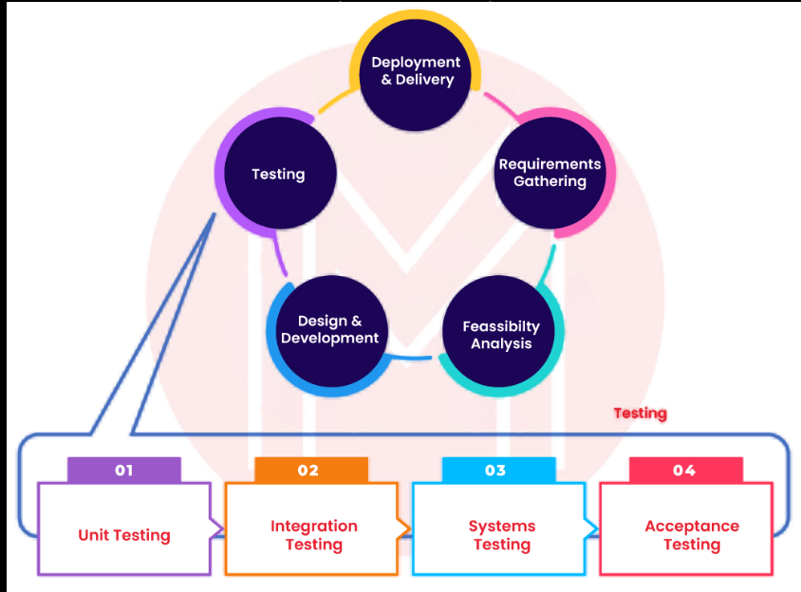

8.2.2 Integration Testing
Integration testing checks whether all modules of the system work together correctly.
The COVID dataset flows from data collection to data processing, visualization, and dashboard modules, ensuring that the entire system operates smoothly.

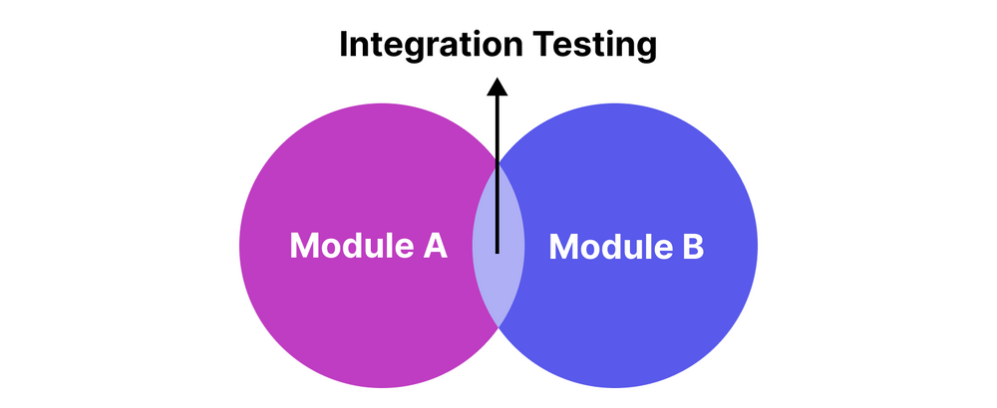

8.2.3 Functional Testing
Functional testing verifies whether the system performs its intended functions.
In this project, it ensures that the system imports COVID datasets, processes data, and generates correct visual dashboards
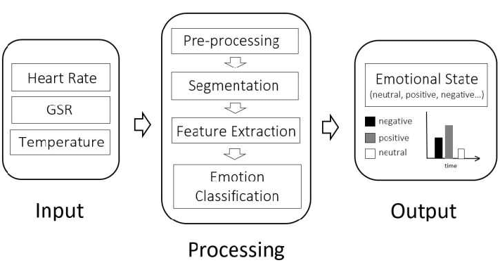

8.2.4 White Box Testing
White box testing focuses on examining the internal structure and logic of the system.
It ensures that the internal data processing steps such as data cleaning, transformation, and analysis work correctly.

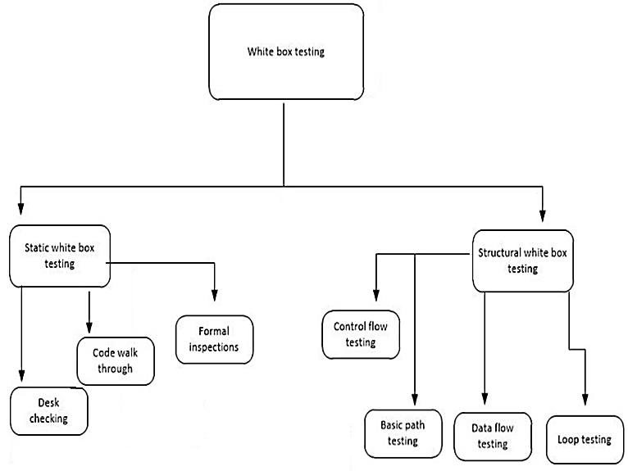

8.2.5 Black Box Testing
Black box testing evaluates the system from the user’s perspective without considering internal processing.
The user uploads the COVID dataset's and verifies whether the system produces correct dashboards and visual insights.

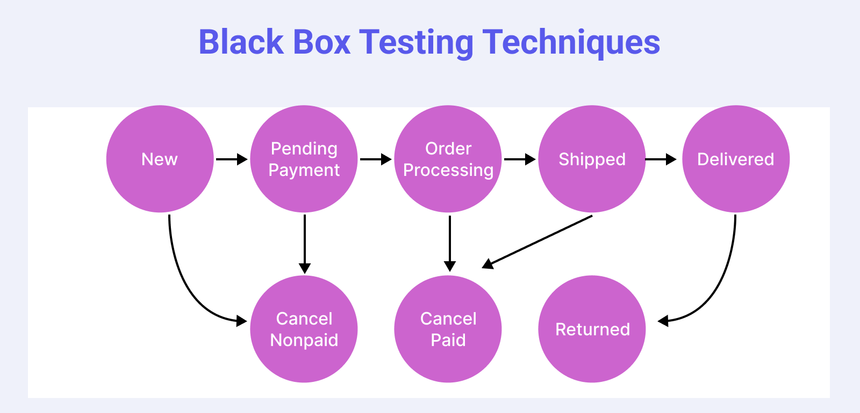

9. PYTHON IMPLEMENTATION CODE

import pandas as pd
import matplotlib.pyplot as plt
import seaborn as sns
# Load dataset
data = pd.read_csv('covid_data.csv')
# Display first rows
print(data.head())
# Plot confirmed cases trend
plt.figure()
data['confirmed'].plot()
plt.title("COVID-19 Confirmed Cases Trend")
plt.xlabel("Date")
plt.ylabel("Cases")
plt.show()
import pandas as pd
import matplotlib.pyplot as plt
import seaborn as sns
# Load dataset
data = pd.read_csv('covid_data.csv')
# Display first rows
print(data.head())
# Plot confirmed cases trend
plt.figure()

data['confirmed'].plot()
plt.title("COVID-19 Confirmed Cases Trend")
plt.x label("Date")
plt.ylabel("Cases")
plt.show()
import pandas as pd
import matplotlib.pyplot as plt
import seaborn as sns
# Load dataset
data = pd.read_csv('covid_data.csv')
# Display first rows
print(data.head())
# Plot confirmed cases trend
plt.figure()
data['confirmed'].plot()
plt.title("COVID-19 Confirmed Cases Trend")
plt.xlabel("Date")
plt.ylabel("Cases")
plt.show()
import pandas as pd
import matplotlib.pyplot as plt
import seaborn as sns
# Load dataset
data = pd.read_csv('covid_data.csv')

# Display first rows
print(data.head())

# Plot confirmed cases trend
plt.figure()
data['confirmed'].plot()
plt.title("COVID-19 Confirmed Cases Trend")
plt.xlabel("Date")
plt.ylabel("Cases")
plt.show()
import pandas as pd
import matplotlib.pyplot as plt
import seaborn as sns
# Load dataset
data = pd.read_csv('covid_data.csv')
# Display first rows
print(data.head())
# Plot confirmed cases trend
plt.figure()
data['confirmed'].plot()
plt.title("COVID-19 Confirmed Cases Trend")
plt.xlabel("Date")
plt.ylabel("Cases")
plt.show()
import pandas as pd
import matplotlib.pyplot as plt
import seaborn as sns
# Load dataset
data = pd.read_csv('covid_data.csv')
# Display first rows
print(data.head())
# Plot confirmed cases trend
plt.figure()
data['confirmed'].plot()
plt.title("COVID-19 Confirmed Cases Trend")
plt.xlabel("Date")
plt.ylabel("Cases")
plt.show()

10. Dashboard Explanation

The dashboard developed in this project provides a clear and interactive visualization of COVID-19 data using Power BI. The dashboard displays important statistics such as total confirmed cases, deaths, recovery rates, and comparisons between countries.
The data is collected from the COVID-19 dataset's and processed using Power BI tools. After data processing, various visual elements such as charts, graphs, and maps are created to present the information in a meaningful way.
The dashboard allows users to interact with the data by applying filters such as country or date. This helps users analyse pandemic trends and understand how COVID-19 spread across different regions.
Main features of the dashboard include:
- Visualization of total COVID-19 cases over time
- Analysis of death rates and recovery statistics
- Comparison of COVID-19 statistics between different countries
- Interactive charts and graphs for easy understanding
The dashboard helps users quickly interpret large datasets and gain valuable insights through visual analytics.

11. Conclusion

This project successfully demonstrates the use of Power BI for COVID-19 data visualization. The system processes COVID-19 datasets and converts raw data into meaningful insights through interactive dashboards.
The project shows how data visualization tools can help users understand complex datasets easily. By using charts, graphs, and dashboards, users can quickly identify trends in COVID-19 cases, deaths, and recovery rates.
The developed dashboard provides an effective way to analyse pandemic data and supports data-driven decision making. Overall, the project highlights the importance of data visualization in modern data analysis.

12. Future Enhancements

Although the current system provides effective visualization of COVID-19 data, several improvements can be made in the future.
Possible enhancements include:
- Integration of real-time COVID-19 data from online sources
- Use of machine learning algorithms to predict future trends
- Development of a web-based dashboard accessible from any device
- Addition of advanced visualizations and interactive features
- Integration with other healthcare datasets for deeper analysis
These enhancements will further improve the system’s analytical capabilities and make it more useful for research and decision-making.

13. References

[1] Microsoft Corporation, Microsoft Power BI Documentation, Microsoft, 2023.
[2] World Health Organization, WHO Corona virus (COVID-19) Reports, WHO Publications, 2022.
[3] Johns Hopkins University, COVID-19 Data Repository, Centre for Systems Science and Engineering, 2022.
[4] Centred for Disease Control and Prevention, COVID-19 Data Tracker Reports, CDC Publications, 2021.
[5] M. Bostock, V. Ogievetsky, and J. Heer, “D3: Data-Driven Documents,” IEEE Transactions on Visualization and Computer Graphics, vol. 17, no. 12, pp. 2301–2309, 2011.
[6] T. Munzner, Visualization Analysis and Design. Boca Raton, FL, USA: CRC Press, 2014.
[7] S. Few, Information Dashboard Design: Displaying Data for At-a-Glance Monitoring. Oakland, CA, USA: Analytics Press, 2012.
[8] C. N. Knaflic, Storytelling with Data: A Data Visualization Guide for Business Professionals. Hoboken, NJ, USA: Wiley, 2015.
[9] P. Sharma and V. Gupta, “Modern Data Visualization Techniques for Business Intelligence,” International Journal of Data Science, vol. 5, no. 2, pp. 45–52, 2022.
[10] R. Kumar and S. Singh, “Interactive Data Visualization using Power BI,” International Journal of Computer Applications, vol. 182, no. 12, pp. 25–30, 2019.
[11] S. Patel et al., “Business Intelligence and Data Analytic s using Power BI,” International Journal of Innovative Technology and Exploring Engineering, vol. 9, no. 6, pp. 1024–1028, 2020.
[12] K. Ramesh and A. Kumar, “Data Visualization Techniques for Large Datasets,” IEEE International Conference on Data Science and Advanced Analytic s, pp. 210–215, 2018.

[13] P. Chen, “Data Visualization for Business Intelligence Applications,” Journal of Data Science and Analytic s, vol. 7, no. 3, pp. 155–162, 2021.
[14] A. Smith and B. Johnson, “Visualization Tools for Data Analytic s,” International Journal of Advanced Computer Science and Applications, vol. 11, no. 4, pp. 320–326, 2020.
[15] S. Lee and J. Park, “Big Data Visualization Techniques and Tools,” IEEE Access, vol. 7, pp. 56789–56799, 2019.
[16] R. Brown, “Business Intelligence and Dashboard Analytic s,” Journal of Information Systems Research, vol. 14, no. 2, pp. 89–95, 2021.
[17] I. Sommerville, Software Engineering, 10th ed., Boston, MA, USA: Pearson Education, 2016.
[18] R. S. Pressman and B. R. Maxim, Software Engineering: A Practitioner’s Approach, 8th ed., New York, NY, USA: McGowan-Hill Education, 2015.
[19] T. Munster, Visualization Analysis and Design, Boca Raton, FL, USA: CRC Press, 2014.
[20] Microsoft Corporation, Microsoft Power BI Documentation, Microsoft Technical Documentation, 2023.

